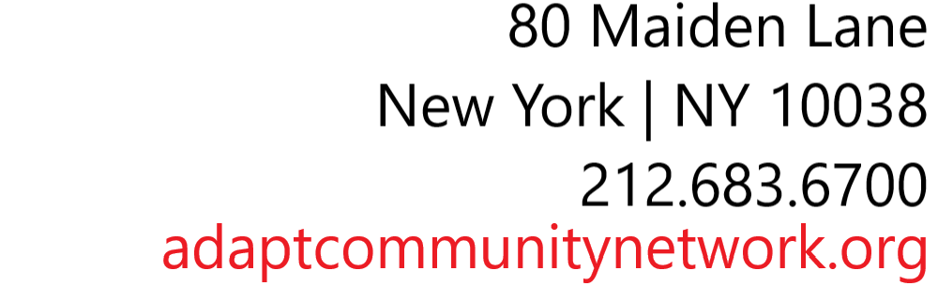

**___________________________________________________________**

**DOORWAYS TO INDEPENDENCE**

ACCESS TO HOME APPLICATION

2020-2021

**DATE OF APPLICATION**: Click or tap to enter a date.**TABS ID (if applicable)**_Click or tap here to enter text.

**I. APPLICATION INITIATOR**

Click or tap here to enter text.

LAST NAME, FIRST NAME TELEPHONE NUMBER EMAIL ADDRESS

Click or tap here to enter text.

RELATIONSHIP TO APPLICANT

**II. APPLICANT INFORMATION (person with disability)**

Click or tap here to enter text.

LAST NAME, FIRST NAME DOB M/F SS # **Medicaid CIN Number**

Click or tap here to enter text.

HOME ADDRESS BOROUGH CITY ZIP

Click or tap here to enter text.

HOME NUMBER CELL PHONE NUMBER EMAIL ADDRESS

Click or tap here to enter text.

CARE COORDINATOR (if applicable) AGENCY TEL: EMAIL ADDRESS

**III. APPLICANT SPECIAL NEEDS/ ACCESSIBILITY NEEDS**

Diagnosis/Nature of Disability: _Click or tap here to enter text.

Date of Onset: Click or tap to enter a date.

**Check any of the following aids if used by the person with disability:**

Walker  Motorized Wheelchair  Manual Wheelchair Crutches  Cane  Visual Aids

Other (Specify) Click or tap here to enter text.

Is the Person with the disability awaiting discharge from a nursing home, rehab facility or other institution?

Yes  No  If yes, name and address of facility: Click or tap here to enter text.

Does the existing living environment pose a health hazard to the applicant or any family members?

Yes No

If yes, explain: Click or tap here to enter text.

Do you believe a home modification will allow you to remain in your home for at least 3 years?

Yes No

**IV. HOUSEHOLD INCOME** (Please include income sources from Wages, Unemployment, Pension, SSI, SSD, Public Assistance, Child Support, Alimony, etc.)

Number of members in the household (including applicant): Click or tap here to enter text.

Click or tap here to enter text.

Name Relationship Birthdate Monthly Income Source

Click or tap here to enter text.

Name Relationship Birthdate Monthly Income Source

Click or tap here to enter text.

Name Relationship Birthdate Monthly Income Source

Click or tap here to enter text.

Name Relationship Birthdate Monthly Income Source

Click or tap here to enter text.

Name Relationship Birthdate Monthly Income Source

Do you or anyone in your family receive Public Assistance? Yes  No  PA Case Number: Click or tap here to enter text.

**V. APPLICANT ETHNICITY/RACE** (Optional)

**Ethnicity: Race**:

Hispanic or Latino  American Indian or Alaska Native

Non-Hispanic  Asian

Black or African American

Native Hawaiian or other Pacific Islander

White

Other: Click or tap here to enter text.

**VI. MODIFICATION NEEDED**

Has this unit previously been repaired or modified with Access to Home Funding? Yes  No

If yes, please describe any repair/modification that has already been done on the house with Access to Home funding and when:

Click or tap here to enter text.

***Please list all needed modifications***

|  |  |  |
| --- | --- | --- |
| Check if needed | Modification Type | Brief description of modification needed |
|  | Wheelchair Ramp | Click or tap here to enter text. |
|  | Wheelchair Lift or Porch Lift | Click or tap here to enter text. |
|  | Interior Stairglide | Click or tap here to enter text. |
|  | Exterior Stairglide | Click or tap here to enter text. |
|  | Accessible Bathroom | Click or tap here to enter text. |
|  | Accessible Kitchen | Click or tap here to enter text. |
|  | Widening of Doorways | Click or tap here to enter text. |
|  | Automatic Door Openers | Click or tap here to enter text. |
|  | Devices for Hearing or Visually Impaired | Click or tap here to enter text. |
|  | Grab Bars/Hand Rails | Click or tap here to enter text. |
|  | Other | Click or tap here to enter text. |

If you could only have one of these modifications/repairs done, which one would you consider priority?

Click or tap here to enter text.

Is the area to be modified the primary living space of the applicant? Yes  No

Is the space to be modified a basement? Yes  No

Any additional information regarding your accessibility needs:

Click or tap here to enter text.

**VII. PROPERTY OWNER INFORMATION** (all property owners must be listed)

Click or tap here to enter text.

PROPERTY OWNER NAME (1)

Click or tap here to enter text.

PROPERTY OWNER NAME (2)

Click or tap here to enter text.

HOME ADDRESS BOROUGH CITY ZIP

Click or tap here to enter text.

HOME NUMBER CELL PHONE NUMBER EMAIL ADDRESS

**VIII. PROPERTY TYPE**

Single Family  Multi Unit (2-4)  Condo  Co Op  Rental

# of Bedrooms: Click or tap here to enter text. # of Bathrooms: Click or tap here to enter text.

Flood insurance company: Click or tap here to enter text.

Homeowner’s insurance company: Click or tap here to enter text.

Is there any reason to be concerned about having the property go into foreclosure? Yes  No

If yes, explain: Click or tap here to enter text.

**IX: PROPERTY MAINTENANCE DECLARATION**

One of the conditions of being assisted with Access to Home funds is that the owner of the modified property must sign a Property Maintenance Declaration (PMD). The Property Maintenance Declaration acknowledges that the unit was improved using Access to Home funds and states that, during the three year regulatory period, the owner will:

* **Maintain the unit in good operating order and condition;**
* **Not sell, move, demolish or materially alter the property without the prior written consent of ADAPT Community Network**
* **If the improved unit becomes vacant during the Regulatory Period, market the unit and make it affordable to persons of low-income and living with a disability.**

The Property Maintenance Declaration is to be signed upon completion of the project and will be recorded in the Office of the City Clerk in which the premises are located, and shall automatically lapse on the termination date. If the eligible participant moves or leaves the unit for any reason within the three year regulatory period, or the PMD is otherwise breached, the Access to Home funds must be repaid on a pro-rated basis over the three years, as outlined:

* **Months 0-12: 100% repayment due**
* **Months 13-24: 67% repayment due**
* **Months 25-36: 34% repayment due**
* **After the 36th month: 0% repayment due**

**Does Property Owner agree to participate in the Home Modification program?** Yes  No

**If assisted, does the Property Owner agree to sign the Property Maintenance Declaration?**  Yes  No

**I/we certify that the above information is true and correct to the best of my/our knowledge. I/we realize that failure to provide all information requested could result in my/our application being invalid. I/we authorize ADAPT Community Network to check any references necessary to complete the processing of this application for the purpose of receiving home repair(s)/home modification(s) through ADAPT Community Network’s Access to Home Program. I/we understand that submission of an application provides no guarantee that work will be performed or creates any duty or obligation on ADAPT Community Network’s behalf. I/we also grant permission to ADAPT Community Network, its employees and any of its consultants/vendors/contractors to conduct site visits at my/our home, to take photos and measurements, as necessary to gauge the scope of work required. I/we also agree to release and hold ADAPT Community Network, its directors and officers, employees, agents, attorneys and volunteers harmless from any course of action, claim or suit arising from, or in connection with this application.**

Click or tap here to enter text.

Applicant Name (Please Print) Date: Click or tap to enter a date.



Applicant Signature Date:Click or tap to enter a date.

Click or tap here to enter text.

Property Owner Name (Please Print) Date: Click or tap to enter a date.



Property Owner Signature Date: Click or tap to enter a date.

**Please remember to include all required additional documents:**

* Individual Income Tax Return (first page of form 1040, showing AGI), Social Security/Disability Award Letter, Bank Statements for all wage earners in home
* Proof of Homeownership (Deed or Mortgage Statement)
* Documentation of any rent received from tenants, if applicable
* Proof of Homeowner’s insurance, if applicable
* Proof of disability (Letter from physician or disability award letter or psychological evaluation, etc.)
* Proof of Medicaid (Medicaid Number) if applicable

**RETURN APPLICATION HERE:**

UCP of NYC DBA

ADAPT Community Network

80 Maiden Lane-2nd Floor

New York, NY 10038

Attn: Terry Hwang

212-683-6700 ext. 1170

Cell:718-594-7374

[mhwang@adaptcommunitynetwork.org](mailto:mhwang@adaptcommunitynetwork.org)

Please send encrypted email to: [mhwang@ucpnyc.org](mailto:mhwang@ucpnyc.org)